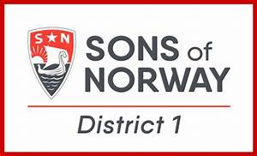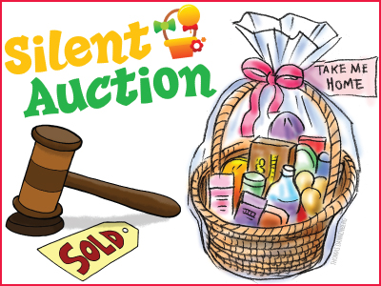
Sons of Norway – District 1 Convention 2024
Hello Lodges of District 1. Following tradition,
there will be a silent auction at the District 1
Convention in Lake Elmo, Minnesota in August.
Proceeds will help fund youth scholarships.
Each lodge of the district is asked to donate one
item for auction. You can send the item with a
convention delegate. Norwegian items are preferred.
We ask that they be in new or like new condition.
Baskets are welcome. You may wish to seek
donations from businesses in your community.
Please reply to this email with information about
your donation: description, value and donor name.
We look forward to a successful silent auction and
say “mange tusen takk” for your lodge’s support.

For the committee, Ron Stow stowronald@gmail.com
Synnove-Nordkap Lodge 1-008 St. Paul, Minnesota

